**A BLOG POST**

**Introduction:**

The Blog Post project is designed to encourage you to write about topics that genuinely interest you. Whether it's a hobby, a current event, a personal experience, or a thought-provoking idea, this project allows you to express yourself and share your insights with others. This user guide will provide you with the necessary steps to get started and make the most of your blogging experience.

In this blog post, we explore the transformative power of gratitude and its ability to shift our perspective, cultivate a positive mindset, and ultimately lead us to a more fulfilling and meaningful life.

Gratitude is more than just saying "thank you." It is a practice, a mindset, and a way of life. It involves consciously acknowledging and appreciating the goodness, abundance, and beauty in both big and small moments. When we embrace gratitude, we open ourselves up to a world of possibilities, joy, and contentment.

Join us on this journey of exploring the power of gratitude and discovering how it can enrich our lives. Let's cultivate a daily practice of gratitude, recognizing and appreciating the blessings that surround us. Together, let's unlock the immense potential of gratitude and create a positive ripple effect that extends far beyond ourselves.

This user documentation will guide you through the system’s process, provide an overview of the system's user interface, and offer detailed instructions on how to perform various tasks and utilize different features.

**User interface overview**

The user interface (UI) of a blog post is a web article you can write on any topic that interests you. You can set up your own blog or contribute to an existing blog through many free and easy-to-use online platforms. You can also make the blog post as long or as short as you want. Writing a blog post allows you to talk about something that interests you and share it with an audience. Here is an overview of the key elements you will encounter within the UI:

**User Interface Description:**

**Dashboard/Homepage:**

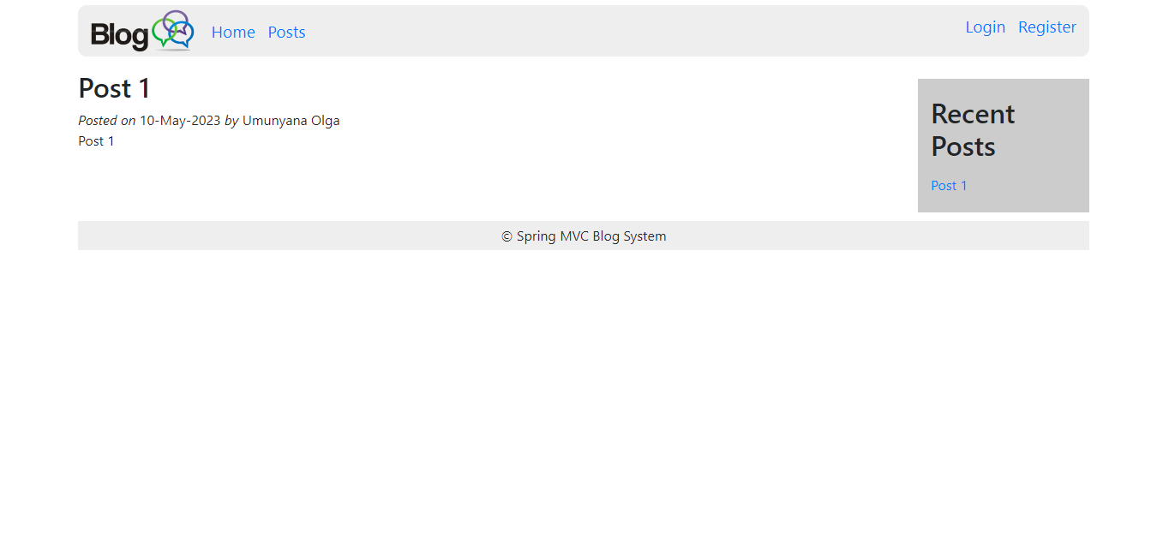Upon logging in, you will be greeted with a user-friendly dashboard or homepage. This is where you can access all the essential features and navigate through your blog.

**Blog Post Creation:**

On the dashboard or toolbar, you'll find a prominent "Create Post" button. Clicking on it will allow you to start creating a new blog post.

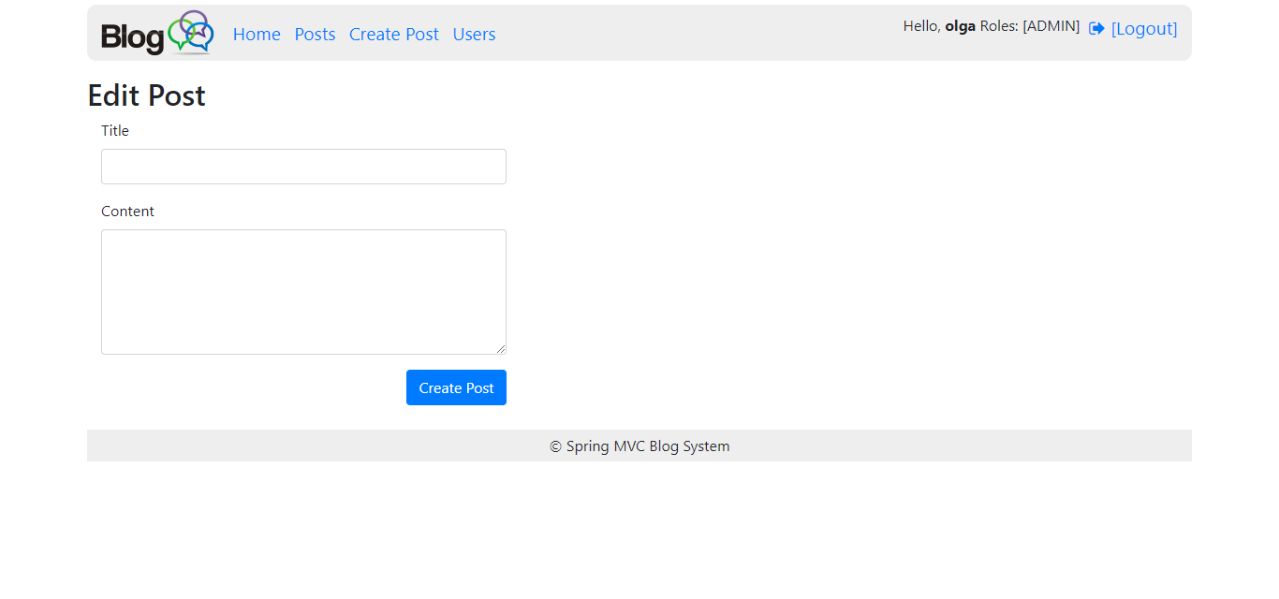

**Title Input Field:**

Enter the title of your blog post in a designated input field. This field may be located at the top of the blog post editor.

Rich Text Editor:

Below the title field, you'll find a robust and intuitive text editor. It enables you to write your blog post using various formatting options such as bold, italics, headings, bullet points, and numbered lists. The editor may also include options for text alignment, font selection, and size adjustments.

Save:

The interface will include a "Create Post" button to manually save your progress. Additionally, an auto-save feature might automatically save your work at regular intervals to prevent data loss.

User Profile:

The interface will offer a user profile section where you can manage your personal information, including your bio, profile picture, and social media links. This adds a personal touch to your blog.